**Data Representation**

**Lab 1: Create HTML page**

**Lecturer: Andrew Beatty**

**Student: Etain Upton G00318876**

1. Done;

<html>

    <head>

        <title>View cars</title>

    </head>

    <body>

    </body>

</html>

I clicked ‘Copy Path’ and pasted into Google Chrome;

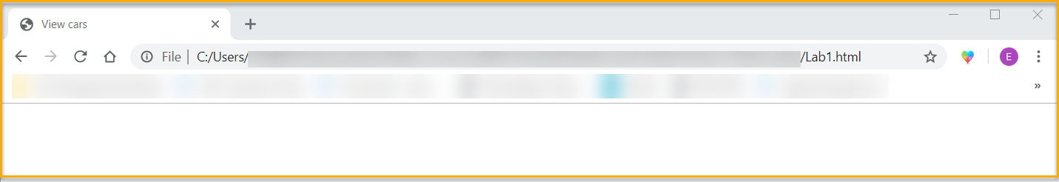

1. Done;

<html>

    <head>

        <title>View cars</title>

    </head>

    <body>

        <h1>Cars</h1>

        <div>Create Button</div>

        <div>

            Table

        </div>

        <div>

            Form

        </div>

    </body>

</html>

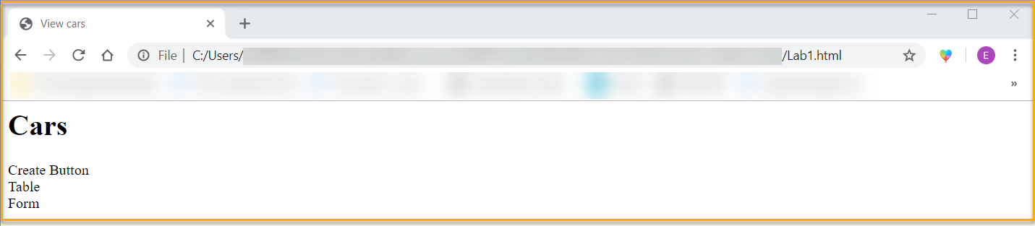

1. Done;

<html>

    <head>

        <title>View cars</title>

    </head>

    <body>

        <h1>Cars</h1>

        <div><button>Create</button></div>

        <div>

            Table

        </div>

        <div>

            Form

        </div>

    </body>

</html>

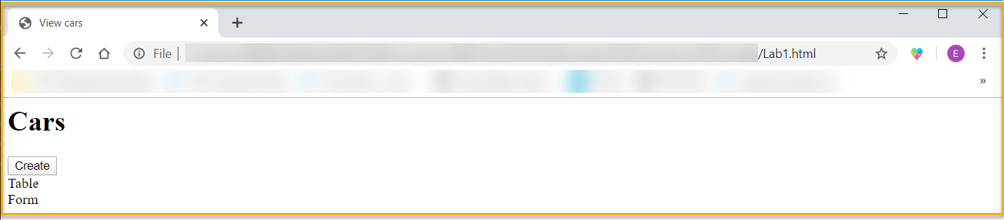

1. Done;

(a)

<html>

    <head>

        <title>View cars</title>

    </head>

    <body>

        <h1>Cars</h1>

        <div><button>Create</button></div>

        <div><h1>All Cars</h1></div>

        <div>

        <table border="1">

            <tr>

                    <th>reg</th>

                    <th>make</th>

                    <th>model</th>

                    <th>price</th>

                    <th>Update</th>

                    <th>Delete</th>

            </tr>

        </table>

        </div>

        <div>

            Form

        </div>

    </body>

</html>

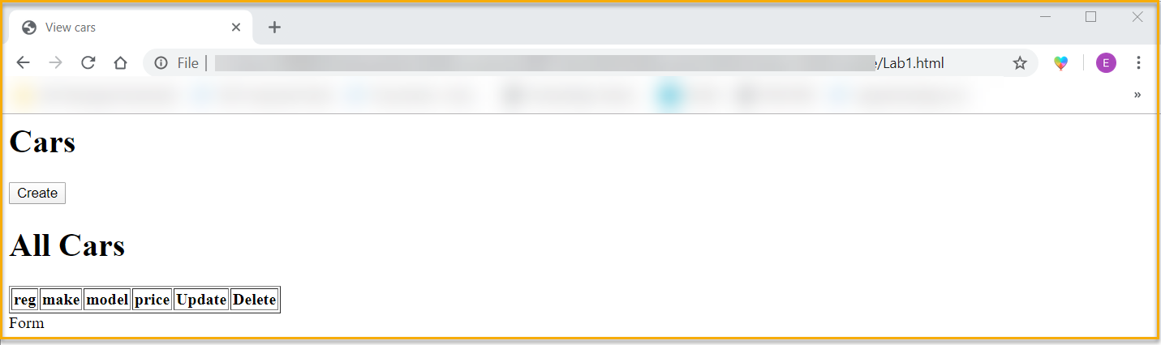

(b)

<html>

    <head>

        <title>View cars</title>

    </head>

    <body>

        <h1>Cars</h1>

        <div><button>Create</button></div>

        <div><h1>All Cars</h1></div>

        <div>

        <table border="1">

            <tr>

                    <th>reg</th>

                    <th>make</th>

                    <th>model</th>

                    <th>price</th>

                    <th>Update</th>

                    <th>Delete</th>

            </tr>

            <tr>

                    <td>191 MO 123</td>

                    <td>Ford</td>

                    <td>Mondeo</td>

                    <td>25,000</td>

                    <td><button>Update</button></td>

                    <td><button>Delete</button></td>

            </tr>

            <tr>

                    <td>131 G 456</td>

                    <td>Ford</td>

                    <td>Fiesta</td>

                    <td>15,000</td>

                    <td><button>Update</button></td>

                    <td><button>Delete</button></td>

            </tr>

            <tr>

                    <td>192 G 111</td>

                    <td>Audi</td>

                    <td>A6</td>

                    <td>40,000</td>

                    <td><button>Update</button></td>

                    <td><button>Delete</button></td>

            </tr>

        </table>

        </div>

        <div>

            Form

        </div>

    </body>

</html>

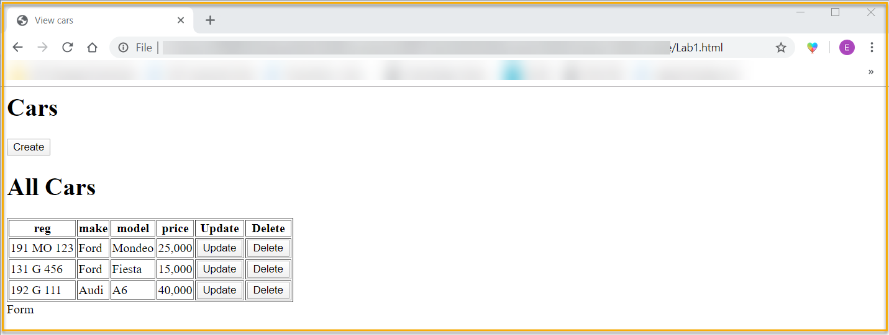

1. Done;

<html>

    <head>

        <title>View cars</title>

    </head>

    <body>

        <h1>Cars</h1>

        <div><button>Create</button></div>

        <div><h1>All Cars</h1></div>

        <div>

        <table border="1">

            <tr>

                    <th>reg</th>

                    <th>make</th>

                    <th>model</th>

                    <th>price</th>

                    <th>Update</th>

                    <th>Delete</th>

            </tr>

            <tr>

                    <td>191 MO 123</td>

                    <td>Ford</td>

                    <td>Mondeo</td>

                    <td>25,000</td>

                    <td><button>Update</button></td>

                    <td><button>Delete</button></td>

            </tr>

            <tr>

                    <td>131 G 456</td>

                    <td>Ford</td>

                    <td>Fiesta</td>

                    <td>15,000</td>

                    <td><button>Update</button></td>

                    <td><button>Delete</button></td>

            </tr>

            <tr>

                    <td>192 G 111</td>

                    <td>Audi</td>

                    <td>A6</td>

                    <td>40,000</td>

                    <td><button>Update</button></td>

                    <td><button>Delete</button></td>

            </tr>

        </table>

        </div>

        <div>

            <h1>Form</h1>

        </div>

                    Reg <input type="text" name="reg"><br/>

                    Make <select name="make">

                            <option value="Ford">Ford</option>

                            <option value="Ford">Ford</option>

                            <option value="Audi">Audi</option>

                        </select><br/>

                    Model <input type="text" name="model"><br/>

                    Price <input type="number" name="price"><br/>

                    </select>

    </body>

</html>

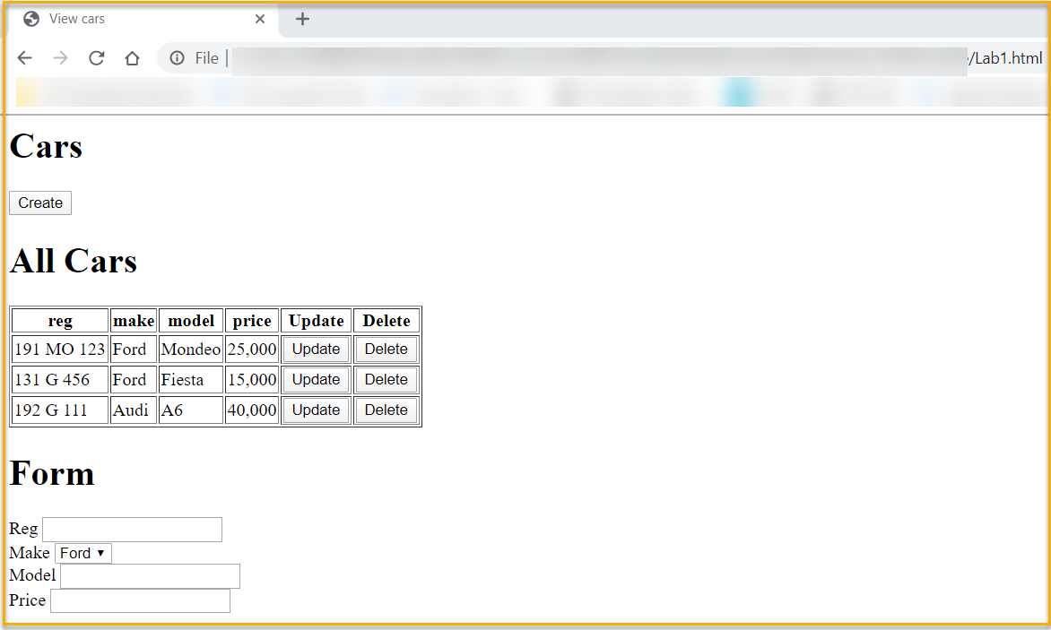

1. Done;

<html>

    <head>

        <title>View cars</title>

    </head>

    <body>

        <h1>Cars</h1>

        <div><button>Create</button></div>

        <div><h1>All Cars</h1></div>

        <div>

        <table border="1">

            <tr>

                    <th>reg</th>

                    <th>make</th>

                    <th>model</th>

                    <th>price</th>

                    <th>Update</th>

                    <th>Delete</th>

            </tr>

            <tr>

                    <td>191 MO 123</td>

                    <td>Ford</td>

                    <td>Mondeo</td>

                    <td>25,000</td>

                    <td><button>Update</button></td>

                    <td><button>Delete</button></td>

            </tr>

            <tr>

                    <td>131 G 456</td>

                    <td>Ford</td>

                    <td>Fiesta</td>

                    <td>15,000</td>

                    <td><button>Update</button></td>

                    <td><button>Delete</button></td>

            </tr>

            <tr>

                    <td>192 G 111</td>

                    <td>Audi</td>

                    <td>A6</td>

                    <td>40,000</td>

                    <td><button>Update</button></td>

                    <td><button>Delete</button></td>

            </tr>

        </table>

        </div>

        <div>

            <h1>Form</h1>

        </div>

                    Reg <input type="text" name="reg"><br/>

                    Make <select name="make">

                            <option value="Ford">Ford</option>

                            <option value="Ford">Ford</option>

                            <option value="Audi">Audi</option>

                        </select><br/>

                    Model <input type="text" name="model"><br/>

                    Price <input type="number" name="price"><br/>

                    <span><button>Create</button></span>

                    <span><button>Delete</button></span>

                    </select>

    </body>

</html>

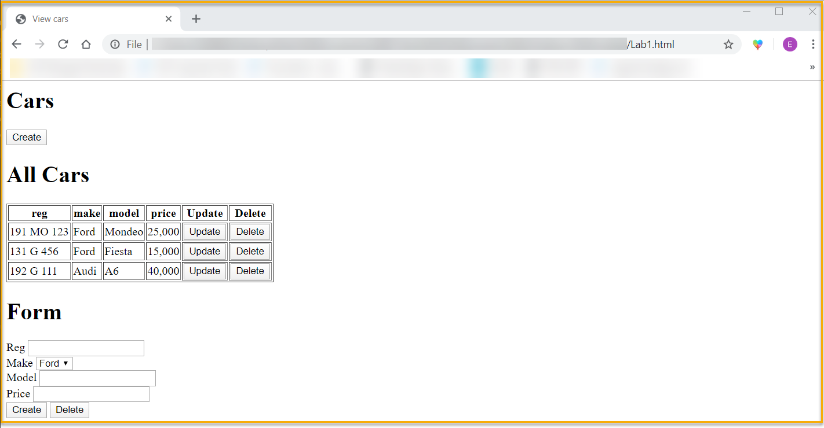

1. Done;

<html>

    <head>

        <title>View cars</title>

    </head>

    <body>

        <h1>Cars</h1>

        <div><button>Create</button></div>

        <div><h1>All Cars</h1></div>

        <div>

        <table border="1">

            <tr>

                    <th>reg</th>

                    <th>make</th>

                    <th>model</th>

                    <th>price</th>

                    <th>Update</th>

                    <th>Delete</th>

            </tr>

            <tr>

                    <td>191 MO 123</td>

                    <td>Ford</td>

                    <td>Mondeo</td>

                    <td>25,000</td>

                    <td><button>Update</button></td>

                    <td><button>Delete</button></td>

            </tr>

            <tr>

                    <td>131 G 456</td>

                    <td>Ford</td>

                    <td>Fiesta</td>

                    <td>15,000</td>

                    <td><button>Update</button></td>

                    <td><button>Delete</button></td>

            </tr>

            <tr>

                    <td>192 G 111</td>

                    <td>Audi</td>

                    <td>A6</td>

                    <td>40,000</td>

                    <td><button>Update</button></td>

                    <td><button>Delete</button></td>

            </tr>

        </table>

        </div>

        <div>

            <h2><span>Create a</span> <span>Update this</span> Car</h2>

        </div>

                    Reg <input type="text" name="reg"><br/>

                    Make <select name="make">

                            <option value="Ford">Ford</option>

                            <option value="Ford">Ford</option>

                            <option value="Audi">Audi</option>

                        </select><br/>

                    Model <input type="text" name="model"><br/>

                    Price <input type="number" name="price"><br/>

                    <span><button>Create</button></span>

                    <span><button>Delete</button></span>

                    </select>

    </body>

</html>

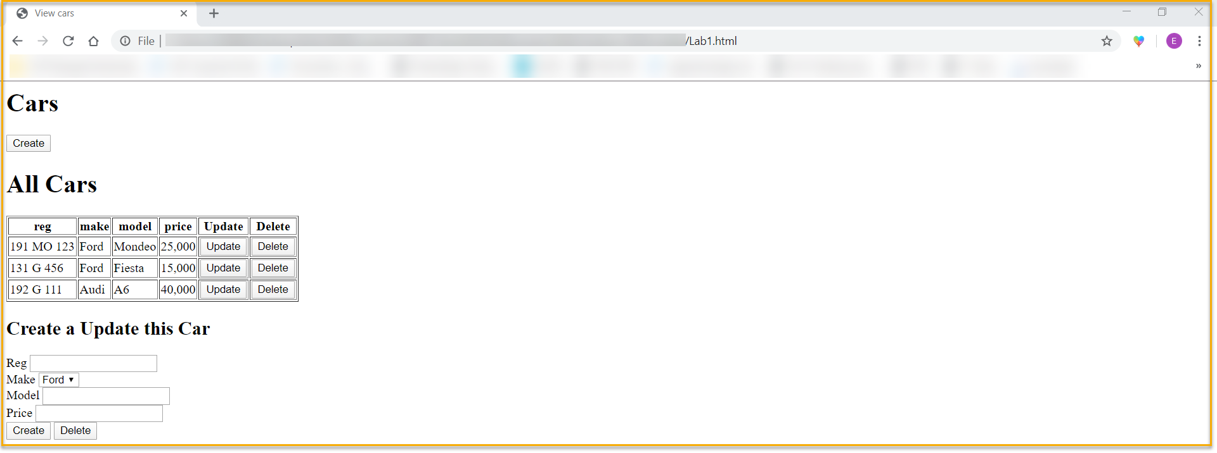

Extra:

1. Done;
2. <html>
3. <head>
4. <title>View cars</title>
5. <link rel="stylesheet" href="https://stackpath.bootstrapcdn.com/bootstrap/4.3.1/css/bootstrap.min.css" integrity="sha384-ggOyR0iXCbMQv3Xipma34MD+dH/1fQ784/j6cY/iJTQUOhcWr7x9JvoRxT2MZw1T" crossorigin="anonymous">
6. </head>
7. <body>
8. <h1>Cars</h1>
9. <div><button>Create</button></div>
10. <div><h1>All Cars</h1></div>
11. <div>
12. <table border="1">
14. <tr>
15. <th>reg</th>
16. <th>make</th>
17. <th>model</th>
18. <th>price</th>
19. <th>Update</th>
20. <th>Delete</th>
21. </tr>
22. <tr>
23. <td>191 MO 123</td>
24. <td>Ford</td>
25. <td>Mondeo</td>
26. <td>25,000</td>
27. <td><button>Update</button></td>
28. <td><button>Delete</button></td>
29. </tr>
30. <tr>
31. <td>131 G 456</td>
32. <td>Ford</td>
33. <td>Fiesta</td>
34. <td>15,000</td>
35. <td><button>Update</button></td>
36. <td><button>Delete</button></td>
37. </tr>
38. <tr>
39. <td>192 G 111</td>
40. <td>Audi</td>
41. <td>A6</td>
42. <td>40,000</td>
43. <td><button>Update</button></td>
44. <td><button>Delete</button></td>
45. </tr>
46. </table>
47. </div>
48. <div>
49. <h2><span>Create a</span> <span>Update this</span> Car</h2>
50. </div>
51. Reg <input type="text" name="reg"><br/>
52. Make <select name="make">
53. <option value="Ford">Ford</option>
54. <option value="Ford">Ford</option>
55. <option value="Audi">Audi</option>
56. </select><br/>
57. Model <input type="text" name="model"><br/>
58. Price <input type="number" name="price"><br/>
59. <span><button>Create</button></span>
60. <span><button>Delete</button></span>
61. </select>
62. </body>
63. </html>

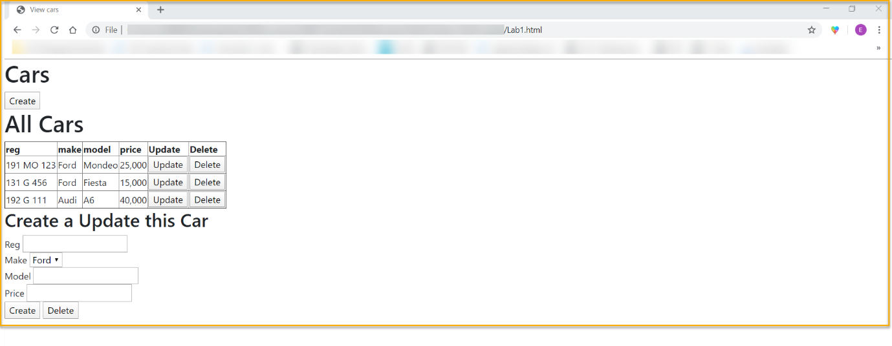

2. Done;

<html>

    <head>

        <title>View cars</title>

        <link rel="stylesheet" href="https://stackpath.bootstrapcdn.com/bootstrap/4.3.1/css/bootstrap.min.css" integrity="sha384-ggOyR0iXCbMQv3Xipma34MD+dH/1fQ784/j6cY/iJTQUOhcWr7x9JvoRxT2MZw1T" crossorigin="anonymous">

    </head>

    <body>

        <h1>Cars</h1>

        <div><button>Create</button></div>

        <div><h1>All Cars</h1></div>

        <div>

        <table class="table">

            <tr>

                    <th>reg</th>

                    <th>make</th>

                    <th>model</th>

                    <th>price</th>

                    <th>Update</th>

                    <th>Delete</th>

            </tr>

            <tr>

                    <td>191 MO 123</td>

                    <td>Ford</td>

                    <td>Mondeo</td>

                    <td>25,000</td>

                    <td><button>Update</button></td>

                    <td><button>Delete</button></td>

            </tr>

            <tr>

                    <td>131 G 456</td>

                    <td>Ford</td>

                    <td>Fiesta</td>

                    <td>15,000</td>

                    <td><button>Update</button></td>

                    <td><button>Delete</button></td>

            </tr>

            <tr>

                    <td>192 G 111</td>

                    <td>Audi</td>

                    <td>A6</td>

                    <td>40,000</td>

                    <td><button>Update</button></td>

                    <td><button>Delete</button></td>

            </tr>

        </table>

        </div>

        <div>

            <h2><span>Create a</span> <span>Update this</span> Car</h2>

        </div>

                    Reg <input type="text" name="reg"><br/>

                    Make <select name="make">

                            <option value="Ford">Ford</option>

                            <option value="Ford">Ford</option>

                            <option value="Audi">Audi</option>

                        </select><br/>

                    Model <input type="text" name="model"><br/>

                    Price <input type="number" name="price"><br/>

                    <span><button>Create</button></span>

                    <span><button>Delete</button></span>

                    </select>

    </body>

</html>

